PRICE LIST - FROZEN CHICKEN

IMAGE | DESCRIPTION | PACKAGING | WEIGHT | AVAILABILITY | PRICE | UNIT
 |  |  |  |  |  | EUR/ KG
CHICKEN
 | chicken breast single with inner | Naked block | 15 Kg | February 2024 ready on stock | 3,69 € | EUR/ KG
 | chicken wings | White Carton | 10 Kg | March 2024 ready on stock | 1,97 € | EUR/ KG
HEAVY HEN
 | heavy hen breast A grade | Block | 15 Kg | February 2024 ready on stock | 3,65 € | EUR/ KG
 | heavy hen feet AB grade | White Carton or Polyblock | 10 Kg | May 2024 | 1,84 € | EUR/ KG
 | heavy hen leg quarters B grade | White Carton | 10 Kg | End March/ April 2024 | 1,49 € | EUR/ KG
 | heavy hen leg quarters cut | Carton | 10 Kg | End March 2024 | 1,72 € | EUR/ KG
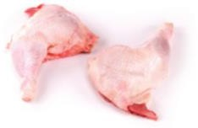 | heavy hen leg quarters | Carton | 10 Kg | March 2024 | 1,72 € | EUR/ KG
 | heavy hen wings | Carton | 10 Kg | April 2024 | 1,72 € | EUR/ KG
 | heavy hen wings B grade | White Carton | 10 Kg | May 2024 | 1,24 € | EUR/ KG
ROOSTER
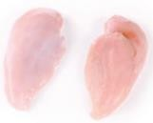 | heavy rooster breast | A grade block | 15 Kg | February 2024 ready on stock | 3,48 € | EUR/ KG
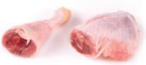 | rooster leg quarters | White Carton | 10 Kg | February 2024 | 1,39 € | EUR/ KG
HEN
 | hen minced meat 3mm | Naked Polyblock | 15 Kg | April 2024 | 3,26 € | EUR/ KG
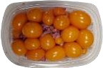 | hen OVARIES 500G | Carton | 0,500 Kg | March 2024 | 3,70 € | 500 GR/ CARTON

 | hen red trimming | Polyblock | 15 Kg | March 2024 | 2,34 € | EUR/ KG
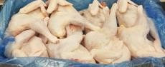 | light hen whole 8-11 pcs | Carton | 10 Kg | March 2024 | 1,89 € | EUR/ KG
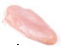 | light hen breast single with inner | Naked block | 15 Kg | March 2024 | 3,75 € | EUR/ KG
 | light hen feet AB grade | White Carton or Polyblock | 10 Kg | March | 0,81 € | EUR/ KG
 | light hen leg quarters | Carton |  | February 2024 ready on stock | 1,90 € | EUR/ KG
 | light hen leg quarters B grade | White Carton | 10 Kg | May 2024 | 1,39 € | EUR/ KG
 | light hen wings | Carton | 9 Kg | March 2023 | 1,73 € | EUR/ KG
 | light hen HALAL | IWP | 1000 - 1700 GR | March 2024 | 2,12 € | EUR/ KG
FRANKS & MORTADELLA
 | chicken Franks CHEESE 340gx 30pcs „Premium Chicken”  brand | Carton |  | March 2024 | 1,87 € | EUR/ KG
 | chicken Franks CREOLE 340gx 30pcs „Premium Chicken”  brand | Carton |  | March 2024 | 1,85 € | EUR/ KG
 | chicken Franks NATURAL 340g x 30pcs „Premium Chicken”  brand | Carton |  | March 2024 | 1,74 € | EUR/ KG
 | chicken Franks SPICY 340gx30pcs „Premium Chicken”  brand | Carton |  | March 2024 | 1,76 € | EUR/ KG
 | chicken Mortadella 1000g „Premium Chicken” brand | Carton | 12 Kg | March 2024 | 1,37 € | EUR/ KG
 | chicken Mortadella 500g „Premium Chicken” brand | Carton | 12 Kg | March 2024 | 1,38 € | EUR/ KG
 | chicken Mortadella Paprica 500g „Premium Chicken” brand | Carton | 12 Kg | March 2024 | 1,51 € | EUR/ KG

